AUTOMATED UNIVERSITY COURSE TIMETABLING WITH AI-DRIVEN FEEDBACK AND CONSTRAINT BASED SCHEDULING
By
Mateo Grifsha
PhD(c). Anxhela Baraj

A THESIS
Submitted to

KOLEGJI UNIVERSITAR “Instituti Kanadez i Teknologjisë”
University College “CANADIAN INSTITUTE OF TECHNOLOGY”

Faculty of Engineering
Department of Software Engineering

In partial fulfillment of the requirements for the degree of:
Bachelor in Software Engineering

Submitted on June 15th, 2026

Approved:
PhD. (c) Anxhela Baraj, Thesis Supervisor ____________________________ (signature)
Dr. Adriola Faqolli, Head of Department ____________________________ (signature)

Copyright
I understand that my thesis will become part of the collection of Canadian Institute of Technology. My signature below authorizes release of my thesis to any reader upon request. I also affirm that the work represented in this thesis is my own work.

Mateo Grifsha, Author ____________________________ (signature)

Table of Contents
Copyright ii
Table of Contents iii
List of Figures v
List of Tables v
Abstract 2
Keywords 2
Acknowledgement 3
I. Introduction 4
I.1 Background and Motivation 4
I.2 Problem Statement 5
I.3 Objectives 5
I.4 Research Questions 6
II. Literature Review 8
II.1 The University Timetabling Problem 8
II.2 Scheduling Algorithms and Constraint Satisfaction 8
II.3 RESTful API Design in Software Systems 8
II.4 Component-Based Frontend Architecture 9
II.5 Relational Data Modeling for Educational Systems 9
III. Methodology 12
III.1 Research design 12
III.1.1 Algorithmic approach 12
III.1.2 Course ordering 12
III.1.3 Hard constraints 13
III.1.4 Soft constraints and scoring 13
III.1.5 Room selection 15
III.1.6 Professor assignment 15
III.1.7 Fallback behavior 15
III.1.8 What the algorithm does not enforce 16
III.1.9 Development approach 16
III.1.10 System architecture 16
III.1.11 Data model 17
III.1.12 Scheduling algorithm 18
III.1.13 Validation 19
III.2 Database design 20
III.2.1 Data storage 20
III.2.2 Business rules 20
III.2.3 Decisions behind some of these rules 22
III.2.4 Database normalization 23
III.2.5 Intentional redundancy for simplicity 24
III.3 Connecting UI with the database 25
III.3.1 Technology choices 25
III.3.2 Directory Structure 26
III.4 User Interface 29
III.4.1 Technology choices 29
III.4.2 Directory structure 31
III.4.2 Data fetching 31
III.4.3 Component interaction and state 31
III.4.4 How data flows through the system 32
III.5 Securing the application 34
III.6 How AI fits into the system 37
IV. Results and discussion 38
IV. 1 Algorithm Setup 38
IV.2 Benchmarking Process 40
IV.3 Dataset and workload 42
IV.3 Feasibility 42
IV.3 Timing breakdown by component 44
IV.3 Single-semester vs 6-semester 46
IV.3 Run-to-run stability 46
IV.4 Discussion 48
IV.4.1 Meaning Behind The Benchmark 48
IV.4.2 Runtime Distribution 49
IV.4.3 Scaling behaviour 49
IV.4.4 Practical takeaways 49
V. Conclusion and Future Work 51
VI. References 52
Appendix A: Data 54

List of Figures
Figure 1. Database Creation Using SQLAlchemy 27
Figure 1. Database Creation Using SQLAlchemy 27
Figure 2. Course model definition and referential constraints between tables 27
Figure 3. Course schema definition for requests and response validation 28
Figure 4. Backend router for fetching information on a specific course via a GET HTTP Method 29
Figure 5. Definition of the response format that TypeScript expects 30
Figure 6. Styling format on an element for supporting dark and light themes 30
Figure 7. How a JSON Web Token is structured to provide security 35
Figure 8. Authentication process when using JWT (https://medium.com/@btanisha528/jwt-explained-211027d49153). 36
Figure 9. Password hashing processhttps://medium.com/@bhupendra_Maurya/password-hashing-using-bcrypt-e36f5c655e09 36
Figure 10.1. Schedules simulated 43
Figure 12. Timing breakdown by component (n = 11, error bars on total = 1 SD) 44
Figure 13. Time distribution in realistic modes 45
Figure 14. Single semester vs full school, runtime per mode 46
Figure 15. End-to-end runtime per scheduling mode (n = 11, error bars = 1 SD) 47
Figure 16. Runtime history per mode across benchmark runs 48

List of Tables
Table 1. day_session_score heuristic values. 18
Table 2. Scheduling constraints by type and affected entity. 19
Table 3. Core data model (SQLAlchemy tables in backend/models.py). 26
Table 4. Comparison of baseline and full scheduling modes. 43
Table 5. Test dataset entity counts. 46
Table 6. End-to-end runtime per scheduling run, in milliseconds. 47
Table 7. Schedules produced per mode (full-school scope). 48

List of Appendices
Appendix A: Data 59

Automated University Course Timetabling with AI-Driven Feedback and Constraint-Based Scheduling

Abstract
The construction of weekly course timetables remains one of the most labour-intensive administrative tasks in higher education. The problem is combinatorially hard: an administrator must simultaneously avoid conflicts in rooms, professors, and student groups, respect physical room capacities, and ideally produce schedules that are compact and equitable. In practice, the task is still performed manually with spreadsheets at many institutions, a process that scales poorly and is highly sensitive to revision. This thesis presents the design, implementation, and empirical evaluation of an automated course timetabling system intended to address those limitations. The system was implemented as a full-stack web application composed of two independent services: a Python backend built with FastAPI, SQLAlchemy, and PostgreSQL, exposing a REST API for both CRUD operations on academic entities and the auto-scheduling engine itself; and a Next.js 16 frontend built with React 19, Tailwind CSS, used by administrators to manage data and inspect generated timetables. Two algorithmic modes are provided. A baseline mode performs a first-fit greedy assignment, while a full mode applies a day-session heuristic that prefers compact teaching days together with load-balanced professor selection. The system was evaluated through a reproducible, seeded benchmarking harness that compared both modes across six problem sizes from five to thirty student groups, with thirty randomised instances per size and a theoretical room-slot saturation point at approximately eighteen groups. The findings indicate that the heuristic mode consistently improves schedule quality over the baseline without sacrificing feasibility within the unsaturated regime. The work demonstrates that a lightweight, deployable system can deliver practically useful timetabling and provides a foundation for extension toward stronger constraint handling and meta-heuristic optimisation.

Keywords
Keywords: University Course Timetabling, Automated Scheduling, Constraint Satisfaction, Greedy Algorithms, Heuristic Optimisation, Day-Load Heuristic, Full-Stack Web Application, REST API, Fastapi, Empirical Benchmarking.

Acknowledgement

Introduction

The allocation of weekly teaching activities to rooms, time slots, and instructors is a recurring administrative task in every higher-education institution. Despite its routine character, the task is structurally complex: each assignment must simultaneously avoid conflicts on three independent resources, rooms, professors, and student groups, while remaining consistent with curricular structure and physical capacity. This chapter situates the present work within that context, states the specific problem the thesis addresses, defines the objectives and research questions that guide the investigation, and outlines the structure of the remaining chapters.

I.1 Background and Motivation

The allocation of weekly teaching activities to rooms, time slots, and instructors is a recurring administrative task in every higher-education institution. Despite its routine character, the task is structurally complex: each assignment must simultaneously avoid conflicts on three independent resources such as rooms, professors, and student groups, while remaining consistent with curricular structure and physical capacity. In a sizeable faculty the number of admissible weekly configurations grows combinatorially with the number of courses, groups, and time slots, and any localised change, such as the unavailability of a single instructor, can propagate through the schedule and require extensive manual revision. The practice of constructing such timetables by hand, often in spreadsheets, is therefore labour-intensive, error-prone, and inherently fragile.
The general problem is well established in the operations research and artificial intelligence literature under the name of the University Course Timetabling Problem (UCTP), and it is known to be NP-hard in its standard formulations. A substantial body of work has investigated the problem through integer programming, constraint programming, and meta-heuristic methods, including simulated annealing, tabu search, and evolutionary algorithms. While these approaches can produce high-quality solutions on representative benchmarks, the resulting systems are frequently monolithic, computationally demanding, and difficult to integrate into the day-to-day administrative workflow of a university.
It is in this gap between theoretical sophistication and operational practicality that the present thesis is situated. A lightweight, deployable web-based solution, built on contemporary frameworks and exposing its functionality through a conventional browser interface, can offer substantial value to administrators even when its underlying algorithm is greedy rather than provably optimal. Modern Python web frameworks such as FastAPI provide high-throughput asynchronous request handling, mature object-relational mappers such as SQLAlchemy allow rich domain models to be persisted in robust relational engines such as PostgreSQL, and component libraries built on top of React enable the rapid construction of usable administrative interfaces. The convergence of these technologies makes it feasible to embed a tractable scheduling engine inside a system that is genuinely usable in production, and the thesis is concerned with exactly that engineering proposition.

I.2 Problem Statement

The system addressed in this thesis must solve a precisely circumscribed instance of the timetabling problem. Given a faculty whose academic structure is captured by the hierarchy of degrees, student groups, course curricula, courses, and professors, the system must produce a weekly schedule that assigns to every (course, student group) pair exactly one Lecture session and one Seminar session, each occupying a two-hour time block, in a designated room, and taught by an eligible professor. The result must be conflict-free in three independent senses: no room may be assigned to two sessions in the same time slot, no professor may be assigned to two sessions in the same time slot, and no student group may be required to attend two sessions in the same time slot. In addition, the capacity of every assigned room must accommodate the size of the corresponding student group.
Beyond strict feasibility, the system seeks to produce schedules of higher pedagogical quality. In particular, it attempts to minimise timetable fragmentation for students by preferring assignments that fill an existing teaching day to two sessions before opening a new day, thereby reducing the number of distinct days on which a student group must attend the institution. The thesis treats this preference not as a hard constraint but as a heuristic objective, embedded in the scheduling algorithm through a per-day session score that is consulted whenever multiple feasible slots remain.
A scoping limitation is acknowledged at the outset. Professor availability is represented in the domain model and may be populated by administrators, but the present scheduling engine treats it as advisory rather than enforcing it as a hard constraint. Strict enforcement of professor availability, together with extension to other soft constraints currently outside the scope of the heuristic, is identified as an area for future work.

I.3 Objectives

The work pursues a small number of concrete engineering and research objectives, which together define the scope of the contribution. The first objective is the design and implementation of a normalised relational data model that captures the full academic hierarchy of the institution, from faculties and degrees down through student groups, course curricula, courses, course schedules, and individual course sessions, together with the supporting entities of professors, rooms, and time slots. The data model is intended to serve both as the persistence layer for the system and as the formal substrate on which the scheduling algorithm operates.
The second objective is the implementation of a REST API backend that exposes both standard CRUD operations on the entities of the domain model and a dedicated auto-scheduling endpoint. The scheduling endpoint supports two algorithmic modes: a baseline mode that performs first-fit greedy assignment with no quality optimisation, and a full mode that augments the same greedy procedure with a day-load heuristic and load-balanced professor selection.
The third objective is the development of a modern web frontend, built on Next.js, React, Tailwind CSS, and shadcn/ui, through which an administrator can manage academic entities and visualise the timetables produced by the backend.
The fourth objective is the design and execution of a reproducible empirical benchmark that compares the two algorithmic modes under controlled conditions. The benchmark varies the number of independent student groups across six problem sizes, from five to thirty groups, with thirty randomised instances per size, and records both feasibility rate and three schedule-quality metrics, denoted S1, S2, and S3, that capture timetable fragmentation, the proportion of compact four-hour days, and professor workload deviation respectively.
The fifth and final objective is the analysis of the resulting data with a view to determining whether the heuristic mode meaningfully improves schedule quality over the baseline, and at what problem scale the greedy scheduler begins to lose feasibility under resource saturation.

I.4 Research Questions

The investigation is guided by four research questions, each of which corresponds to a measurable property of the implemented system. The first question (RQ1) asks whether a greedy scheduling algorithm, embedded in a conventional REST API, is capable of producing conflict-free weekly timetables for realistic university curricula at interactive response times. The second question (RQ2) examines whether the addition of a day-load heuristic, specifically, the day-session score that prefers compact four-hour teaching days, significantly reduces student timetable fragmentation, both in terms of the number of distinct active days per student group and in terms of the proportion of days that contain exactly two sessions.
The third question (RQ3) concerns equity in the assignment of teaching load. It asks how the load-balanced professor selection used in the full mode affects the deviation between the most and least loaded professors, relative to the first-available selection used in the baseline mode. The fourth and final question (RQ4) is concerned with the behaviour of the system under increasing demand. It asks at what problem scale, expressed as the number of independent student groups, the greedy scheduler begins to lose feasibility due to room-slot saturation, and whether the heuristic mode degrades differently from the baseline in that regime. The benchmark instances are dimensioned such that the theoretical saturation point lies at approximately eighteen groups, placing both unsaturated and saturated regimes within the experimental range.

Literature Review

II.1 The University Timetabling Problem

University timetabling is a well-studied combinatorial optimization problem that has been formally defined in the research literature for decades. Ceschia, Di Gaspero, and Schaerf (Ceschia, Di Gaspero, & Schaerf, 2022) provide a comprehensive survey of six standard timetabling formulations, covering problem structure, benchmark datasets, and the state of current algorithmic solutions. Their work establishes the distinction between hard constraints, which must not be violated (a room cannot hold two groups at the same time), and soft constraints, which represent preferences that should be satisfied where possible.
This distinction maps directly to real deployment scenarios. Davison, Kheiri, and Zografos (Davison, Kheiri, & Zografos, 2024) extend the classical formulation to account for hybrid teaching modes, where courses must be assigned to physical rooms or online slots depending on session type, which reflects the kind of Lecture and Seminar session distinction this system implements. Ye, Jovine, van Osselaer, Zhu, and Shmoys (Ye, Jovine, van Osselaer, Zhu, & Shmoys, 2024) demonstrate a real-world deployment at Cornell University where integer programming was applied to final exam scheduling, handling hard constraints such as room capacity and student conflict avoidance at institutional scale.

II.2 Scheduling Algorithms and Constraint Satisfaction

The scheduling problem belongs to the broader class of constraint satisfaction problems, where a solution must be found that satisfies a set of restrictions over a discrete set of variables. Kiyohara and Ishihata (Kiyohara & Ishihata, 2024) apply constraint programming to course scheduling with an additional fairness objective, demonstrating how conflict-free assignment and preference satisfaction can be combined in a single model.
Dunke and Nickel (Dunke & Nickel, 2023) present a three-tier matheuristic that combines integer programming with a genetic algorithm for multi-level university timetabling, validated on approximately 2,000 students at a German university. Their layered approach, separating lecture plan generation, tutorial assignment, and individual student timetable construction, is relevant to systems where scheduling must be performed at the level of student groups rather than individual students.

II.3 RESTful API Design in Software Systems

The REST architectural style has become the dominant approach for exposing application functionality over HTTP in web-based systems. Kotstein and Bogner (Kotstein & Bogner, 2021) conducted a Delphi study with eight industry experts to evaluate 82 REST API design rules, finding that 28 were rated as highly important and that adherence most significantly affected usability, maintainability, and compatibility. Their findings support organizing backend routes by resource type and maintaining consistent path conventions, both of which are practices this system follows. Bogner, Wojcik, and Zimmermann (Bogner, Wojcik, & Zimmermann, 2024) investigate how common API structuring patterns affect understandability in a controlled experiment with 65 participants, reinforcing that the route-per-resource approach commonly used in frameworks like FastAPI produces more maintainable systems than monolithic alternatives.

II.4 Component-Based Frontend Architecture

React-based frontend architectures organize user interfaces as trees of composable components, where each component manages its own state and renders independently. Pati and Zaki (Pati & Zaki, 2025) compare React.js and Next.js directly on performance metrics including First Contentful Paint and Time o Interactive, finding that Next.js provides consistent performance advantages particularly under constrained network conditions.
Chen (Chen, 2025) proposes a modular rendering and adaptive hydration architecture for Next.js applications, showing how selective component hydration reduces unnecessary client-side JavaScript execution. Both studies provide context for the decision to use Next.js as the application framework, particularly its handling of the client/server rendering boundary through the use client directive.

II.5 Relational Data Modeling for Educational Systems

Relational databases remain the standard storage layer for educational information systems because the data is inherently structured and the relationships between entities (faculties, degrees, student groups, courses, rooms) require referential integrity guarantees. [Siberian Federal University authors] (Siberian Federal University, 2023) analyze existing university information systems and propose a relational schema for higher education institutions using SQL Server, focused on supporting data-driven management decisions. Lyu, Shen, and Matsuzawa (Lyu, Shen, & Matsuzawa, 2026) present a simplified educational database prototype that explores the design tradeoffs involved in building database-backed academic applications, particularly the tension between schema normalization and query complexity.

The literature surveyed reveals a consistent pattern: existing research on university timetabling concentrates heavily on the algorithmic layer of the problem while treating the surrounding system as secondary or out of scope. Ceschia et al. (Ceschia, Di Gaspero, & Schaerf, 2022), Dunke and Nickel (Dunke & Nickel, 2023), and Kiyohara and Ishihata (Kiyohara & Ishihata, 2024) all evaluate their contributions against abstract benchmark datasets or simulate scheduling runs against pre-loaded data. None of them address the full lifecycle of a scheduling system, which includes the initial setup of institutional data (faculties, degrees, student groups, rooms and time slots), the management of curriculum entries that determine which courses belong to which year and semester, the triggering of schedule generation through a user interface, and the subsequent ability to inspect and manually correct the output. The gap between a scheduling algorithm and a deployable scheduling tool is rarely addressed in the literature.

A related gap concerns transparency. Commercial scheduling systems such as CELCAT, TimeEdit, and Unit4 Timetabler are widely deployed at European universities, but they are proprietary, expensive, and provide limited visibility into why a particular course could not be scheduled. When the algorithm fails to place a course-group pair, the user is typically told that a conflict exists without being shown which specific resource (professor availability, room capacity, or slot saturation) caused the failure. This system addresses that gap directly: when a course cannot be scheduled, the _diagnose_no_slot function in auto_schedule.py analyses the conflict sets in memory and returns a human-readable explanation identifying exactly which resource categories are the bottleneck, whether that is a fully booked professor, no rooms with sufficient capacity, or overlapping group commitments. This diagnostic output is surfaced in the frontend as a per-entry breakdown in the skipped courses panel.

A further gap concerns the integration of automatic generation with manual correction. The papers surveyed treat schedule generation as a terminal step: the algorithm produces a solution and the evaluation is complete. In practice, generated schedules frequently require manual adjustment, because professors have informal preferences that the system does not capture, rooms are sometimes unavailable for institutional reasons outside the data model, or administrators simply want to swap two sessions for logistical convenience. This system provides that capability: after generation, every session in the timetable can be individually reassigned to a different time slot and room through an inline edit dialog, with conflict detection still enforced server-side on the PUT request. The combination of automated generation as a starting point and manual override as a finishing step is not addressed as a design objective in the reviewed literature.

Finally, the reviewed work on relational database design for educational systems focuses on schema design as an end, without connecting it to the scheduling use case. The schema in this system is specifically structured around the scheduling algorithm's needs: the CourseCurriculum table acts as the join between a course, a degree, a year level, and a semester, and it is the entry point the algorithm iterates over. The CourseSchedule and CourseSession tables are distinct entities so that a single course offering can have two sessions (Lecture and Seminar) with independently assignable slots and rooms. This two-level output model, one schedule record per course-group pair and two session records per schedule, is not a design that emerges naturally from generic educational database schemas and represents a contribution specific to the scheduling domain.

Methodology

The system methodology describes how the system was designed, built, and validated. The goal was a working software artifact that solves a real scheduling problem. The approach, architecture, algorithm design, and validation strategy are each covered in turn, with trade-offs explained where the decisions were not obvious. Meanwhile the actual implementation environment is separated between two parts, a web accessible NEXT.js application view, and the work being done behind the scenes via a FastAPI backend. Everything will finally be tied to a PostgreSQL instance to handle data storage.

III.1 Research design

III.1.1 Algorithmic approach

The scheduler is greedy. It works through curriculum entries one at a time, places each course if it can, and commits the placement to memory before moving on. There is no backtracking. If an early placement blocks a later one, the later course is skipped and reported in the API response, the algorithm does not retry with a different earlier choice.

A complete constraint satisfaction solver would guarantee finding a valid schedule if one exists, but it requires translating the problem into a formal constraint language and its runtime can grow sharply with instance size. The greedy approach is faster, easier to extend, and easier to debug. For the scheduling instances this system handles, it performs well without that overhead.

III.1.2 Course ordering

Curriculum entries are sorted by difficulty weight before scheduling begins, from highest to lowest. Harder courses are placed first. The reason is practical: a high-difficulty course placed late in the run has fewer available slots to choose from, because lighter courses have already consumed resources. Sorting by difficulty reduces the risk of a demanding course being stranded by earlier, lower-stakes placements. Similarly the number of course sessions per day, as displayed in Table 1, is based on a score that does not allow for more than 3 course sessions in a day.
Table 1. day_session_score heuristic values
Existing sessions on day | Score | Effect
0 | 1 | Opens a new day (acceptable)
1 | 0 | Best: completes a 4-hour student day
2 | 2 | Discouraged: produces a 6-hour day
3+ | 99 | Hard avoid: would exceed 6 hours

III.1.3 Hard constraints

Three conflict sets are maintained in memory throughout the run.

- The professor conflict set records (professor_id, slot_id) pairs, a professor cannot be assigned to two sessions in the same slot.
- The student group conflict set records (group_id, slot_id) pairs, a student group cannot appear in two sessions simultaneously.
- The room conflict set records (room_id, slot_id) pairs, a room cannot host two sessions at the same time.
- The professor availability set records (professor_id, slot_id) pairs where a professor's declared availability windows do not cover the slot, those combinations are blocked before scheduling begins, not checked reactively during it.

Every candidate slot and room is checked against all four sets. A candidate that fails any one of them is discarded. There is no priority ordering among the three at this stage, the check is a flat rejection, not a ranking.

Before the run begins, these sets are pre-populated from sessions already in the database, so re-running generation on a partially scheduled semester does not produce conflicts with existing sessions.

III.1.4 Soft constraints and scoring

After hard constraints are cleared, candidates are scored. Lower scores are preferred.

- The main soft constraint is day utilization. The goal is to fill a student group's day to roughly four hours before opening a new one. A slot on a day where the group already has one session scores 0, placing there produces a compact four-hour day. A slot on a day with no existing sessions scores 1, opening a new day is fine but not the first choice. A slot on a day with two existing sessions scores 2. A slot on a day with three or more sessions scores 99 and is skipped entirely, since that would push the group past six hours on a single day.

- The second soft constraint tries to put the lecture and seminar for each course on different days. Once the lecture is placed, the seminar search applies a same-day penalty to any slot that falls on the lecture's day. The penalty scales with the course difficulty weight: 5.0 + (difficulty_weight × 3.0). A course with weight 1.0 adds a penalty of 8.0; a course with weight 2.0 adds 11.0. Heavier courses are pushed harder toward a different day.

- The third soft constraint discourages stacking difficult courses on the same day for a given group. Each successful placement increments a per-group, per-day difficulty accumulator. When scoring candidates, the accumulated weight for a day is divided by 10 and added to the slot's score. Days that already carry heavy courses become slightly less attractive for the next heavy course.

All three scores are summed into a single value per (slot, room) pair based on the constraints on Table 2. The lowest-scoring combination is selected.
Table 2. Scheduling constraints by type and affected entity
Constraint | Type | Entity affected
No two sessions share a (professor, slot) | Hard | Professor
No two sessions share a (group, slot) | Hard | Student group
No two sessions share a (room, slot) | Hard | Room
Room capacity >= group size | Hard | Room, group
Each course has one Lecture and one Seminar | Hard | Course schedule
Lecture and Seminar on different days | Soft | Group
Professor availability window covers slot | Soft | Professor
Max courses per group (default 10) | Soft | Group
Day fill prefers 4-hour student days | Soft | Group
Heavier courses spread across days | Soft | Group

III.1.5 Room selection

Rooms are loaded in ascending order of capacity before the run begins. For any given time slot, the algorithm picks the first room in that ordered list that fits the student group's capacity and is not already occupied. The smallest satisfactory room is assigned first. Larger rooms are left available for groups that need them.

When multiple student groups take the same course, they can share a room for a given session if the combined student count fits within the room's capacity. Rather than treating the room as occupied after the first group is placed, a running occupancy counter tracks how much of the room's capacity has been claimed. A subsequent group for the same course at the same slot can use the same room if there is enough space remaining. A room is only treated as fully occupied once no further combining is possible.

III.1.6 Professor assignment

Two modes are available. Baseline always picks the first professor assigned to a course. Full mode picks the professor with the fewest sessions in the current run, based on a load counter that increases by two with each successful placement, one for the lecture, one for the seminar. These spreads teaching load across the faculty without a global optimization pass. It is greedy load balancing, not an optimal assignment.

III.1.7 Fallback behavior

If the scoring phase finds no valid candidates, every available slot either violates a hard constraint or lands on a day already at its session limit, the algorithm falls back to a relaxed search that drops the day-fill requirement. It still prefers a different day from the lecture but will accept the same day if nothing else works.

If the fallback also fails, the course-group pair is skipped. The API response includes a diagnostic entry identifying the limiting resource: professor fully booked, group with no free slots, no room large enough, or some combination. This gives the administrator something concrete to act on rather than a generic failure message.

III.1.8 What the algorithm does not enforce

Professor double-booking and weekly recurring availability are both enforced as hard constraints. What the system does not currently enforce is one-off date-specific absences. A separate table captures these calendar exceptions, but the scheduler does not consult it. Recurring weekly availability windows are fully enforced; specific exception dates are not.

III.1.9 Development approach

The system was developed iteratively, with the data model defined first and the scheduling algorithm built on top of it. This order mattered. Several decisions that would affect the algorithm, whether student groups or individual students are the unit of scheduling, how the curriculum is represented, how professor assignments work, needed to be settled before any scheduling logic was written. Starting with data modeling forced those decisions to be explicit early, rather than discovering them mid-algorithm as implicit assumptions.

Development was split into two workstreams: the backend API and the frontend interface, built and tested separately. The backend could be exercised entirely through HTTP requests, PowerShell scripts for bulk data seeding, curl for scheduling operations, which meant the algorithm could be validated before any UI existed. The frontend was added as a layer on top of the already-working API.

This separation also simplified debugging. If the scheduler produces a bad result, the problem is in the backend. If the interface shows wrong data, the problem is in the frontend. A clear boundary between the two gives bugs a known half of the system to start from.

III.1.10 System architecture

The system has two independent components: a REST API backend and a browser-based frontend.

The backend runs on FastAPI (Python) with a PostgreSQL database accessed through SQLAlchemy. FastAPI was chosen for its automatic OpenAPI documentation, useful during development for manually testing endpoints, and its async support. SQLAlchemy handles the ORM (Object-Relationship Mapping) layer, mapping Python model classes to database tables, which keeps the schema derived from the code rather than maintained as a separate artifact.

The frontend is a Next.js 16 application using React 19 and Tailwind CSS. It communicates with the backend through REST calls only. There are no Next.js API routes, the frontend is a pure client talking directly to the FastAPI server. This keeps the architecture simple and makes the backend API the single source of truth for all data.

III.1.11 Data model

The data model reflects how university curricula are actually structured rather than imposing an abstract scheduling model onto the domain. The hierarchy is: Faculty → Degree → StudentGroup → Student. A StudentGroup, something like "Software Engineering Year 2, Group A", is the fundamental scheduling unit. Individual students are registered within groups, but the scheduler operates at the group level. Scheduling individual students would multiply the constraint space without changing what the output looks like.

The curriculum is represented through a CourseCurriculum table, which records which courses belong to which degree, year, and semester. This is separate from the Course table itself, so the same course can appear in multiple degree programs without duplication. The scheduler reads CourseCurriculum entries to determine what needs to be placed for a given (year_level, semester_number) pair, not semester IDs, but the logical pair, because administrators think in terms of "Year 3, Semester 2," not database row identifiers.

Each scheduled course produces a CourseSchedule record linking the course to the student group, and exactly two CourseSession records: one Lecture and one Seminar. Each session references a TimeSlot and a Room. The one-lecture-one-seminar structure reflects the standard academic session format and is baked into the algorithm rather than left as a runtime configuration.

III.1.12 Scheduling algorithm

The scheduler uses a greedy heuristic approach. For a given (year, semester) pair, it iterates over all active CourseCurriculum entries and attempts to place each one. For each entry, it identifies all matching StudentGroups for that degree, year, and semester; selects a professor; finds a valid time slot and room for the Lecture session; then finds a different valid combination for the Seminar session; and records the placements in memory before moving to the next entry.

Two professor-selection modes were implemented. Baseline picks the first available professor for each course. Full mode uses load balancing: it counts how many sessions each eligible professor has already been assigned in the current run and picks the one with the fewest. This spreads teaching load more evenly without requiring a global optimization pass.

The decision to use a greedy algorithm rather than a complete constraint satisfaction solver was made consciously. A complete solver, SAT-based or integer programming, can guarantee optimality but requires translating the problem into a formal constraint language and slows down as instance size grows. A greedy approach is faster, easier to debug, and easier to extend with new heuristics. The trade-off is that it can fail to find a valid schedule even when one exists, if early placements block later ones. For scheduling instances of the size this system targets, this has not caused failures during testing, but it is worth acknowledging as a property of the approach rather than a solved problem.

The algorithm includes a day utilization heuristic, day_session_score, that tries to fill a day to four hours before opening a new one. A day with one existing session scores 0 (preferred, adding to it continues filling the day); a day with no sessions scores 1 (neutral, opening a new day is fine but not the first choice); a day with two sessions scores 2 (less preferred); a day with three or more is skipped entirely. This produces schedules where sessions cluster on fewer days rather than scattering thinly across the week, which reduces unnecessary commute days for students and fragmentation for professors.

Conflict tracking happens entirely in memory during a scheduling run, using sets that record occupied (room, time_slot), (professor, time_slot), and (student_group, time_slot) combinations. Checking set membership is fast, and keeping this state in memory rather than
querying the database on every placement keeps generation time low. The downside is that an interrupted run leaves no partial state to recover from, the run either completes or the database is unchanged.

III.1.13 Validation

Correctness is verified through a dedicated validation endpoint that queries the database for all CourseSession records in a given (year, semester) pair and checks for the three conflict types. This is a post-generation check rather than an assertion inside the algorithm. Running it separately means it can be triggered at any point, including after manual edits, not just immediately after generation. It also means the validation logic can be tested independently from the scheduling logic, which would be harder if the two were interleaved.

A benchmark suite measures schedule generation time across different semester configurations. Generation completes well under one second for typical semester loads. The benchmark also verifies that validation returns no conflicts after a successful run, connecting performance measurement to correctness confirmation in a single pass.

III.2 Database design

III.2.1 Data storage

PostgreSQL was chosen as the database because the data model is relational and well-suited to a relational store. The constraints, foreign keys, and joins that make scheduling logic correct are things PostgreSQL handles reliably. SQLite would have worked for a single-user local tool, but PostgreSQL is closer to what a real university deployment would use. The database is structured around a hierarchy that mirrors the real university: faculties contain degrees, degrees contain student groups, and student groups are the unit that courses get scheduled against. Modelling the hierarchy this way means queries that need to find all groups belonging to a particular faculty or degree can follow the foreign key chain rather than filtering on denormalized fields. Infrastructure such as rooms, time slots, and session types is stored as reference data that the scheduling process reads but does not modify, which means a scheduling run can never accidentally corrupt the room list or time slot configuration. Each successful scheduling run writes one CourseSchedule record per course-group pair and exactly two CourseSession records attached to it, one for the lecture and one for the seminar. Keeping sessions as separate records means each one can be individually reassigned to a different slot or room without touching the parent record, which is what makes the inline edit feature in the frontend possible without additional schema complexity.
SQLAlchemy is used as the ORM layer between Python and PostgreSQL. Rather than writing raw SQL, the schema is defined as Python classes in models.py and SQLAlchemy translates them to tables. This means any change to the data model only needs to happen in one place, eliminating the risk of the code and the database diverging silently. It also means queries are written in Python, which makes them easier to read, compose, and refactor than raw SQL strings.

III.2.2 Business rules

1. A faculty can have multiple degrees, and each degree belongs to exactly one faculty.
2. A degree can have multiple student groups, and each student group belongs to exactly one degree.
3. A student group can have multiple students enrolled in it, but each student belongs to exactly one student group.
4. Each professor and each student has exactly one user account, and each user account belongs to either one professor or one student, never both.
5. A professor can be assigned to multiple courses, and a course can have multiple professors assigned to it.
6. A course can appear in multiple curriculum entries across different degrees, and each curriculum entry belongs to exactly one course.
7. A degree can have multiple curriculum entries, and each curriculum entry belongs to exactly one degree.
8. A student group can have multiple course schedules, and each course schedule belongs to exactly one student group.
9. A course can have multiple schedules across different student groups, and each schedule belongs to exactly one course.
10. Each course schedule has exactly two sessions attached to it, one lecture and one seminar, and each session belongs to exactly one schedule.
11. A time slot can be referenced by multiple sessions, and each session occupies exactly one time slot.
12. A room can host multiple sessions across different time slots, and each session takes place in exactly one room.
13. A professor can have multiple weekly availability records, and each availability record belongs to exactly one professor.
14. A professor can have multiple one-off unavailability records, and each belongs to exactly one professor.
15. A student group can have multiple availability records, and each availability record belongs to exactly one student group.
16. A user can submit multiple complaints, and each complaint belongs to exactly one user.

Based on these business rules, the database was created with the entities and the relationships shown in Table 3.

Table 3. Core data model (SQLAlchemy tables in backend/models.py)
Table | Purpose | Key relationships
Faculty | Top-level academic unit | 1:N to Degree
Degree | Programme within a faculty | N:1 Faculty, 1:N StudentGroup
StudentGroup | Cohort sharing a schedule | N:1 Degree, 1:N Student
Student | Individual enrolled in a group | N:1 StudentGroup
Prof (User) | Professor with assigned courses | M:N Course (professor_course)
Course | Catalogue entry | M:N Prof, 1:N CourseSchedule
CourseCurriculum | Which course belongs to which (degree, year, semester) | N:1 Course, N:1 Degree
CourseSchedule | One scheduled offering (course + group) | N:1 Course, N:1 StudentGroup
CourseSession | Lecture or Seminar instance | N:1 CourseSchedule, N:1 TimeSlot, N:1 Room
TimeSlots | (day, start_time, end_time) tuple | Referenced by CourseSession
Rooms | Physical room with capacity | Referenced by CourseSession
ProfessorAvailability | Per-professor working window | Read by auto_schedule, stored only
SessionTypeModel | Enum table (Lecture, Seminar) | Referenced by CourseSession

III.2.3 Decisions behind some of these rules

Rule 4: single User table for professors and students

Both professors and students need login credentials, names, and email addresses. Rather than duplicating those fields across two tables, a single user table stores all shared identity data with a u_role enum to distinguish the two roles. Separate prof and student tables then hold role-specific data and reference user via a foreign key. This is called Class Table Inheritance: the common fields live in the parent, the role-specific fields live in the child. The trade-off is that reading a full professor profile requires a join, but it avoids the update anomaly where changing someone's email would need to happen in two places.

Rule 5: professor-course as many-to-many

A professor can teach several courses across a semester, and a course may have multiple professors available to teach it. This forced a junction table (professor_course) rather than a foreign key on either side. The scheduling algorithm then queries this table to find all eligible professors for a given course and picks among them based on load or order depending on the mode.

Rules 6 and 7: CourseCurriculum as a separate table

The most significant structural decision was separating what a course is from where it appears in a curriculum. If degree_id, year_level, and semester_number were columns on the course table, each course could only belong to one degree at one year level. A shared prerequisite course that appears in multiple degree programs would need to be duplicated as separate rows with different names, an obvious problem. The course_curriculum table solves this by making curriculum placement its own entity: a course exists once, and can be linked into as many curricula as needed. The scheduler reads course_curriculum to decide what to place, not the course table directly.

Rule 10: two-level CourseSchedule + CourseSession structure

A course offering for a given student group needs two sessions per week, a lecture and a seminar, which may be in different rooms at different times. Storing both on a single record would require either nullable columns for the second session or a fixed layout that cannot extend to other session counts. Instead, CourseSchedule records the what (which course, which group, which professor), and CourseSession records each individual when and where. One schedule always produces exactly two sessions. This separation also makes the validation endpoint straightforward: it queries sessions for conflicts without needing to know anything about the parent schedule structure.

Rules 11 and 12: TimeSlots and Rooms as reference tables

Time slots and rooms are pre-defined records rather than free-form strings on each session. This does two things: it constrains scheduling to a fixed set of valid time windows and known rooms, which prevents malformed data, and it makes conflict detection during the scheduling run a simple set membership check on integer IDs rather than string comparison or range overlap logic. The scheduler loads all slots and rooms once at the start of a run and operates entirely on those lists in memory.

III.2.4 Database normalization

The database schema conforms to Third Normal Form (3NF) across all relations. To satisfy 3NF, a table must first satisfy First Normal Form (1NF) and Second Normal Form (2NF), then additionally contain no transitive dependencies: no non-key attribute may be determined by another non-key attribute.

All tables satisfy 1NF. Every table has a single-column primary key, all column values are atomic, and there are no repeating groups or array-valued fields. Enumerated values such as day_of_week, u_role, and session_type are stored as database-level enums rather than free-form strings, which enforces atomicity at the storage layer.

All tables satisfy 2NF automatically. The only table with a composite primary key is professor_course, which has no non-key attributes at all, so partial dependencies cannot arise. Every other table uses a surrogate integer primary key, which makes 2NF trivially satisfied since all attributes depend on that single key.

For 3NF, the one genuine violation that was identified and corrected was in the student_degree table. In its original form the table stored deg_id and yr_lvl alongside group_id. Since each group already carries its degree and year level in student_group, those two attributes were transitively determined through a non-key path: group_id was a foreign key into student_group, which determined both deg_id and yr_lvl. That is a textbook transitive dependency. The fix was to remove deg_id and yr_lvl from student_degree entirely, leaving the table with only its primary key and group_id. The degree and year level are now read from student_group whenever they are needed.

III.2.5 Intentional redundancy for simplicity

Two areas of the schema contain intentional redundancy that does not violate 3NF in the strict formal sense but is worth acknowledging.

The first is the course table, which stores c_year, c_semester, and degree_id directly on the course record. The course_curriculum table already captures this information as part of a course's curriculum placement. Within the course table itself there is no transitive dependency: c_year, c_semester, and degree_id all depend directly on c_id and on nothing else, so 3NF is not broken. The redundancy exists because the frontend course management interface uses these fields to display and filter courses without joining to the curriculum table. Removing them would require the courses page to query course_curriculum for every course listed, adding joins and complexity to an interface that is not part of the scheduling logic. The trade-off was accepted: the data is slightly duplicated, but the UI layer stays simple.

The second is course_schedule, which stores room_id, slot_id, and session_type_id even though the child course_session records already carry the same fields for each individual session. Again, within course_schedule no non-key attribute determines another, so 3NF holds formally. The duplication is a header record pattern: course_schedule acts as a parent record describing the offering, while course_session records the individual lecture and seminar placements. The fields on the parent refer specifically to the lecture session and were retained because several API endpoints serialize course_schedule directly using a Pydantic schema that expects those fields. Removing them would require restructuring five endpoints and the corresponding frontend types, for no gain in scheduling correctness.

In both cases the redundancy is bounded and documented. The course_curriculum table remains the authoritative source for scheduling decisions, and course_session remains the authoritative source for where and when each individual session takes place.

III.3 Connecting UI with the Database

The frontend is a browser application. Browsers cannot connect directly to a PostgreSQL database; they have no database drivers, no credentials storage that is safe to expose to the client, and no way to enforce business logic such as conflict checking or load balancing. A backend sits between the two: it accepts HTTP requests from the browser, applies logic, queries the database, and returns structured responses. It is also the single place where scheduling rules are enforced. If the frontend were replaced or a different client were built, the rules would not need to be rewritten.

III.3.1 Technology choices

FastAPI was chosen as the web framework. The main practical reason is that FastAPI generates an interactive OpenAPI documentation page at /docs automatically from the route definitions and Pydantic schemas. During development this meant every endpoint could be tested directly in the browser without writing a separate test client or curl command for each one.

Pydantic handles request and response validation. Every endpoint that accepts a request body expects a Pydantic model, and every response is validated against one. If a request arrives with a missing required field or a wrong type, FastAPI rejects it with a 422 error before the route function is ever called. This pushes validation to the boundary of the system rather than leaving it to be caught somewhere inside a route.

Uvicorn is the ASGI server that runs the FastAPI application. It is the process that actually listens on port 8000 and forwards incoming HTTP connections to the application. ASGI, the Asynchronous Server Gateway Interface, is the successor to the older WSGI standard and is what allows FastAPI to handle requests asynchronously. Uvicorn was chosen because it is the server FastAPI is designed and benchmarked against, and it supports hot-reloading during development so the server restarts automatically when source files change.

python-dotenv loads environment variables from a .env file at startup, which allows the DATABASE_URL to be configured per environment without hardcoding credentials in the source. This means the same codebase can connect to a local development database or a production instance simply by swapping the .env file, without any code changes. The .env file is excluded from version control so credentials are never committed to the repository.

III.3.2 Directory Structure

The folders are structured into 5 main areas, each storing a core part of the way that data is treated, from the initiation of the database tables to the routing of different HTTP Methods, up to the any of the CRUD operations being made on the database.

main.py is the entry point. It does four things in order: loads environment variables, drops and recreates all database tables on startup (so the schema is always fresh and matches the current models), creates the FastAPI application instance, and registers every router. Nothing else lives in main.py. Business logic, models, and schemas each live in their own files.

database.py sets up the SQLAlchemy engine and session factory. It reads DATABASE_URL from the environment, defaulting to a local PostgreSQL instance. It also defines the get_db like in Figure 1 dependency function, which opens a database session, yields it to the route, and closes it when the request is finished. Every route that needs database access declares db: Session = Depends(get_db) in its signature, and FastAPI injects the session automatically.

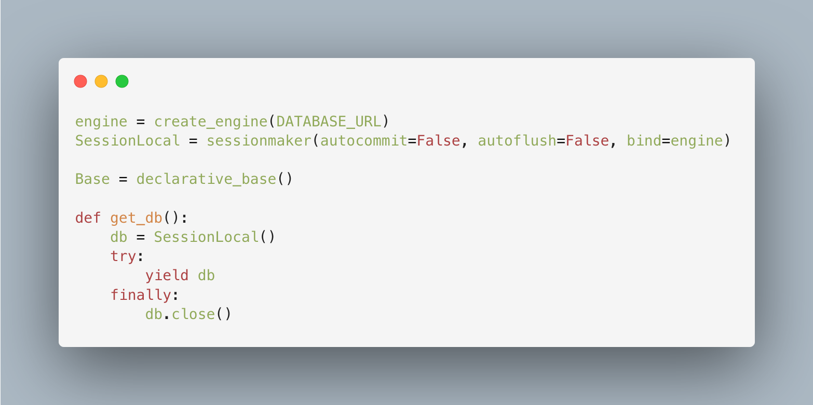
Figure 1. Database Creation Using SQLAlchemy

models.py defines all SQLAlchemy model classes. Each class maps directly to a database table. Relationships between tables are declared here using SQLAlchemy's relationship() construct as we can see in Figure 2, which allows navigating between related objects in Python without writing joins manually.

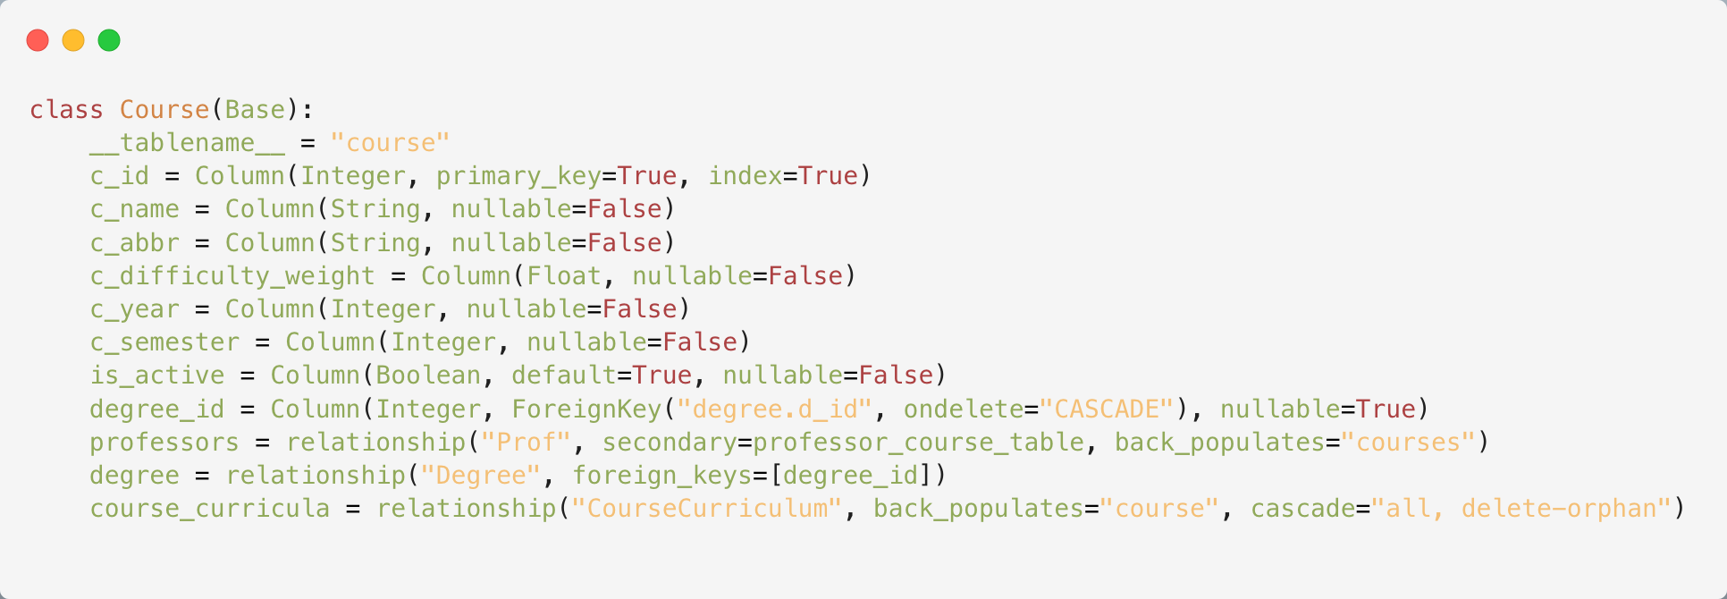
Figure 2. Course model definition and referential constraints between tables

schemas.py defines all Pydantic models used for request and response validation. Each database entity typically has three schema classes: a base class with the shared fields, a create class used for incoming POST requests, and a read class that adds the primary key and timestamps for outgoing responses. Keeping schemas separate from models means the database shape and the API shape can differ where needed as it is seen on Figure 3, for example excluding password fields from responses or accepting degree_ids as a list in the course creation payload even though the database stores a
single degree_id.

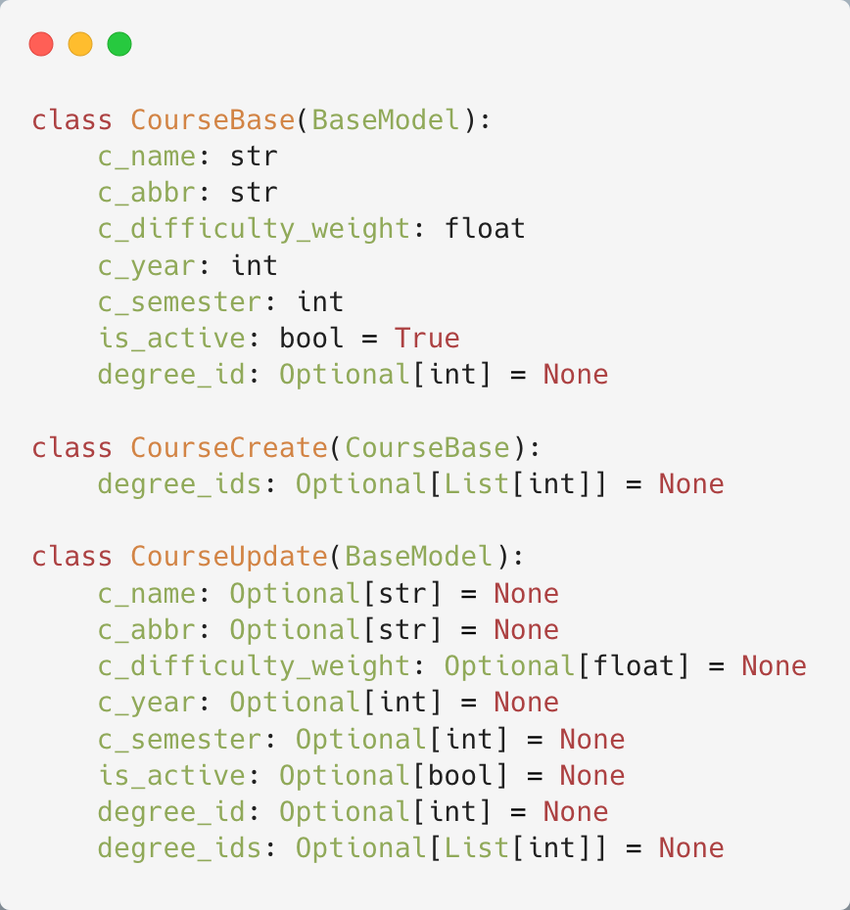
Figure 3. Course schema definition for requests and response validation

The routes/ folder contains one file per resource. Each file creates a FastAPI APIRouter, defines the endpoint functions (like the GET example we have on Figure 4) for that resource, and imports only what it needs from models.py and schemas.py.

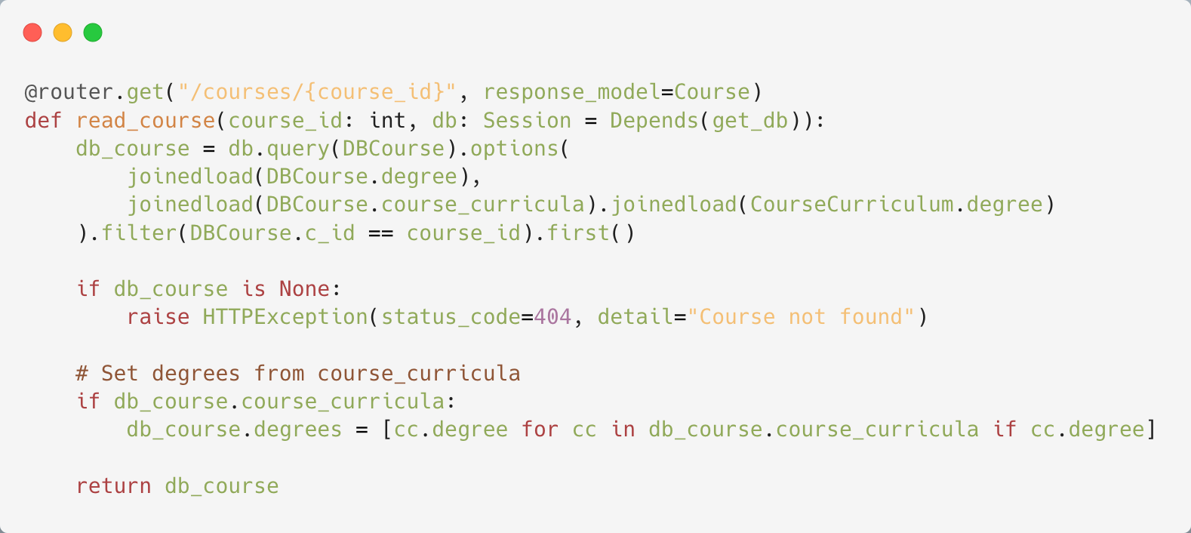
Figure 4. Backend router for fetching information on a specific course via a GET HTTP Method

The routes/__init__.py imports every router and re-exports them so main.py can import them all from one place. This keeps main.py clean: it calls app.include_router() once per router, and that is all it knows about each resource.

III.4 User Interface Design

The backend exposes a REST API, but a REST API by itself is not a useful tool for a scheduling administrator. Someone needs to be able to trigger schedule generation, inspect the results, spot conflicts, and reassign individual sessions without writing curl commands. The frontend provides that interface. It is a browser application that talks directly to the backend over HTTP, with no intermediate server of its own.

III.4.1 Technology choices

Next.js was chosen as the React framework. The application is entirely client-side in terms of data access, meaning the frontend calls the backend API from the browser rather than from any Next.js server-side functions. Next.js still provides value here: it handles TypeScript compilation, module bundling, hot module replacement during development, and a consistent project structure.

TypeScript is used throughout the frontend. All API response shapes are defined as types in a single file, like seen in Figure 5, components/schedule-types.ts. When the backend returns a schedule generation response, TypeScript knows the exact shape of that response at compile time. This caught several field-name mismatches during development that would otherwise only have surfaced at runtime.
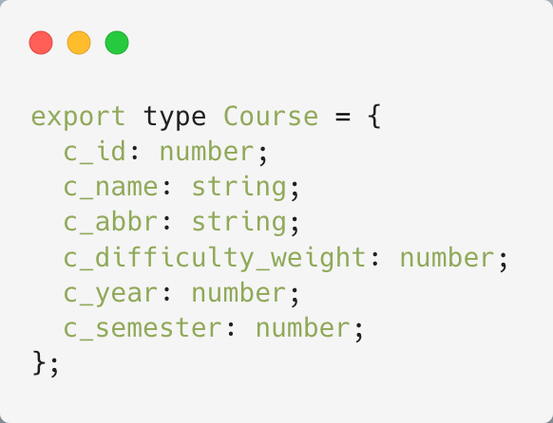
Figure 5. Definition of the response format that TypeScript expects

Tailwind CSS handles all styling. Rather than maintaining separate CSS files, styles are written as utility classes directly on elements. The application supports both light and dark themes, managed by the next-themes library, which applies a dark class, as seen on the example on Figure 6, to the root HTML element and lets Tailwind's dark: variants handle the rest.
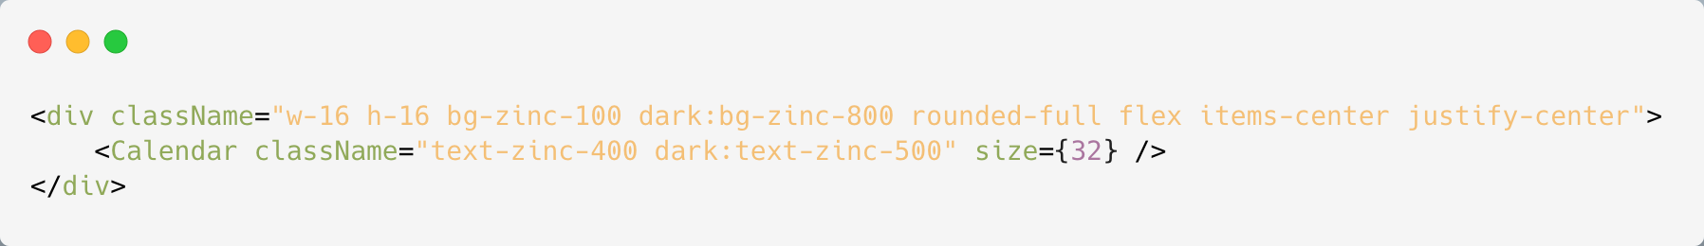
Figure 6. Styling format on an element for supporting dark and light themes

Framer Motion handles entrance animations on panels and result cards. When the auto-scheduler returns a result, the result card fades in from below rather than appearing instantly. This is a small detail, but it makes the interface feel less like raw data and more like a tool with feedback.

Lucide React provides the icon set. Every action button and status indicator uses an icon from this library, which keeps the visual language consistent across panels.

Sonner provides the toast notification system. It is registered once in layout.tsx as a global Toaster component and can be triggered from any component.

III.4.2 Directory structure

The frontend follows the Next.js App Router convention. Page components live under app/, each in their own folder with a page.tsx file. Reusable components live under components/.

These are the building blocks of the dashboard: AutoSchedulePanel, CourseSchedulesPanel, SetupPanel, and others. Each panel is a client component, marked with the "use client" directive at the top of the file. This directive is required in Next.js App Router whenever a component uses React state or lifecycle hooks, since the default rendering model is server-side.

lib/constants.ts holds shared values such as API_BASE and the ordered list of weekdays. Centralising these means the base URL and the day ordering are defined in one place rather than scattered across components.

III.4.2 Data fetching

All API calls use the native browser fetch function. There is no data-fetching library. The ScheduleDashboard component defines a small apiFetch helper that prepends API_BASE to the path, sets the Content-Type header, and throws an error if the response status is not in the 2xx range. Every component that needs data calls this helper or calls fetch directly.

Initial data loads are triggered inside useEffect hooks with an empty dependency array, which runs once after the component mounts. Where multiple independent resources are needed at the same time, the calls are fired in parallel using Promise.all. The CourseSchedulesPanel, for example, fetches time slots and rooms simultaneously on mount since neither depends on the other.

III.4.3 Component interaction and state

ScheduleDashboard is the root component of the scheduling section. It owns shared state that multiple panels need, specifically the list of student groups, degrees, and time slots. It passes these down as props along with shared handler functions for saving and deleting records. Panels that manage only their own data, such as CourseSchedulesPanel, fetch independently and do not share state with the parent.

The active tab is tracked in state within ScheduleDashboard. Only the panel corresponding to the active tab is rendered. This means panels that are not in view do not mount and do not issue fetch requests until the user navigates to them.

Skeleton components are rendered in place of real content while data is loading. The timetable grid shows placeholder rows at the correct dimensions, and the dashboard overview shows placeholder cards. This prevents layout shifts when data arrives and communicates that something is loading rather than leaving the user looking at an empty page.

The AutoSchedulePanel triggers a validation request automatically after a successful generation, with a short delay, so the user sees both the generation summary and the validation result without having to click a second button. The clear action is gated behind a confirmation dialog to prevent accidental deletion.

III.4.4 How data flows through the system

Every interaction in the application follows the same path: the browser makes an HTTP request, Uvicorn receives it, FastAPI routes it, Pydantic validates it, a route function executes against the database through SQLAlchemy, and a response travels back the same way.

The frontend calls the backend using the native fetch API. A typical request looks like this: the AutoSchedulePanel builds a URL from the API_BASE constant and the selected year and semester, then sends a POST to /auto-schedule/generate. The request travels over HTTP to localhost:8000, where Uvicorn is listening.

Uvicorn is an ASGI (Asynchronous Server Gateway Interface) server. It accepts the raw TCP connection, parses the HTTP request, and hands it to the FastAPI application as an ASGI event. Before routing, the request passes through the CORS middleware registered in main.py. This middleware adds the appropriate Access-Control-Allow-* headers to the response, which is what permits a browser page served from port 3000 to call an API on port 8000. Without it, the browser would block the request before it left the client.

FastAPI then matches the incoming path and method against its registered routes. Each router is registered in main.py with app.include_router(), and each route function is decorated with the method and path it handles. When the path matches, FastAPI inspects the function signature to determine what to inject. Query parameters declared in the signature are extracted from the URL automatically. Request bodies are expected to match a Pydantic schema, and if a required field is missing or has the wrong type, FastAPI rejects the request immediately with a 422 Unprocessable Entity response before the route function is ever called. This means validation happens at the boundary of the system, before any database connection is opened, and the error response points to exactly which field failed.

For a simple write, such as creating a course, the route function receives the validated data along with the injected session. It constructs a Course SQLAlchemy model instance, calls db.add() to register it with the session, then db.commit() to flush the pending INSERT to PostgreSQL

The function returns the created object, FastAPI compares it against the response schema, and the frontend receives the newly created record as JSON, including its auto-assigned primary key. For a read, such as loading the timetable for a student group, the route queries CourseSchedule rows filtered by group, joins in the associated sessions, course names, and professor names, and returns the assembled result. SQLAlchemy translates all of this into SQL. No connection is held open while the user reads the page.

The auto-schedule generation route follows the same pattern but does substantially more work inside the route function. When POST /auto-schedule/generate arrives, the function opens a session and immediately loads everything it needs for the full operation: curriculum entries for the requested year and semester, all time slots, all rooms, all session types, and all professor availability records.

Querying the database inside the slot-assignment loop for each course-group pair would produce many small queries that could interfere with the state being built up in memory. Instead, all data is loaded once, and the scheduling algorithm works entirely against in-memory Python collections.

It builds three conflict sets tracking which professor, group, and room are already assigned to which slot, and fills them as it assigns sessions. Once all courses have been processed, a single db.commit() writes every new record to PostgreSQL in one transaction. If the commit fails, none of the records are saved. The response sent back to the frontend includes the full list of created schedule details and any course-group pairs that were skipped, with a diagnostic reason for each.

If any route raises an HTTPException, FastAPI catches it and returns the corresponding HTTP status code with the detail field as the response body. The frontend checks response.ok after every fetch call and, if it is false, reads the body to extract the error message and surfaces it to the user.

III.5 Securing the application

Authentication in the system is handled through JSON Web Tokens (JWT), a standard for representing claims securely between two parties. A JWT is a compact, URL-safe string composed of three parts separated by dots: a header, a payload, and a signature. The header identifies the algorithm used
to sign the token. The payload is a JSON object (seen on Figure 7) containing claims, which are statements about the user and the token itself. The signature is produced by encoding the header and payload with a secret key, and it is what allows the server to verify that the token has not been tampered with since it was issued. Because the signature covers the entire payload, any modification to the payload after issuance will cause signature verification to fail.

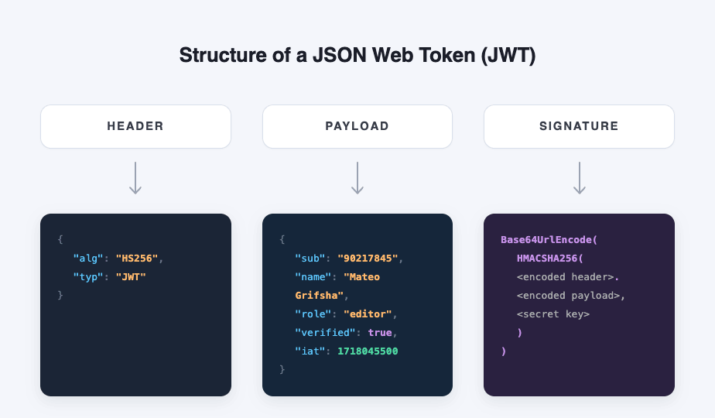
Figure 7. How a JSON Web Token is structured to provide security

When a user submits their credentials to POST /auth/login, the backend queries the database for a matching username and verifies the submitted password against the stored hash using bcrypt. If the credentials are valid, the backend constructs a payload containing three application-specific claims: sub, set to the user’s username and used as the primary identifier; u_id, the numeric primary key of the user record; and u_role, the user’s role in the system, either student or professor. A fourth claim, exp, is added automatically and set to eight hours from the time of issue, after which the token is considered expired and will be rejected. The backend then signs this payload using the HS256 algorithm (HMAC with SHA-256) with a secret key loaded from the JWT_SECRET_KEY environment variable, producing the final token string, which is returned to the client.

On subsequent requests the client includes the token in the Authorization header as a Bearer token. FastAPI’s OAuth2PasswordBearer dependency extracts the token from the header automatically. The get_current_user dependency function then decodes and validates the token using python-jose, checks that the username in the sub claim corresponds to a real user in the database, and returns that user object to the route. If the token is missing, expired, or the signature does not match, FastAPI returns a 401 Unauthorized response before the route function is called, which is visually displayed in the graphic in Figure 8. Crucially, the server does not need to store tokens anywhere. The signature alone is sufficient to verify authenticity, which means authentication adds no database reads beyond the single user lookup.

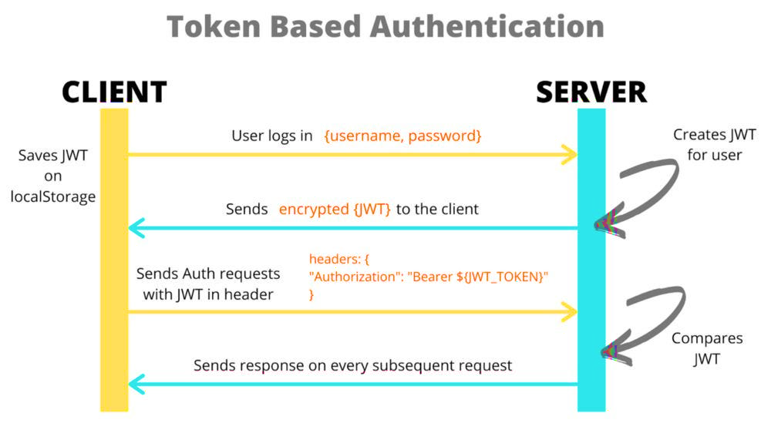
Figure 8. Authentication process when using JWT (https://medium.com/@btanisha528/jwt-explained-211027d49153).

The user model stores a role field with two possible values: student and professor. This role is embedded in the JWT payload at login time and is available to any route that depends on get_current_user, allowing routes to enforce role-based access by checking current_user.u_role against the required role. Passwords are hashed through passlib using the bcrypt scheme, through the function seen in Figure 9. Plain-text passwords are never stored or logged anywhere in the system. Bcrypt is a password hashing function designed to be computationally slow, which makes brute-force attacks against a leaked password database significantly more expensive than with faster algorithms such as MD5 or SHA-256.

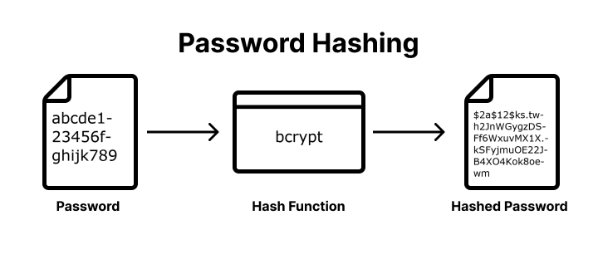
Figure 9. Password hashing processhttps://medium.com/@bhupendra_Maurya/password-hashing-using-bcrypt-e36f5c655e09

III.6 How AI fits into the system

AI shows up is the complaints and resolutions flow, which is where it closes a loop between users and the schedule. A student or professor files a complaint, the system summarizes it, classifies the underlying issue, and proposes a resolution. A human still clicks accept or edits the text before anything ships, so the administrator stays in charge of the final call. What gets handed off is the triage.

The most concrete example is the make-up session flow in backend/routes/ai_suggestions.py. When the administrator accepts a suggestion, the backend does not just store it, it rebuilds the full notification email from the accepted payload. The endpoint takes the group, the course (matched by either c_name or c_abbr), the missed date, the missed slot, and the LLM's suggested slot string, something like "Friday 13:00-15:00". It then resolves the professor and the original room by walking CourseSchedule and CourseSession. The suggested weekday is anchored to the missed date through _next_date_for_weekday, which finds the first matching weekday strictly after the absence. If the suggestion lands on the same weekday as the missed session, it pushes a full week out so the announcement clearly points at a future date.

From there the subject is a fixed template, Make-up Session Rescheduled, {c_abbr} ({session_type}). The body works the same way: a hardcoded letter that drops in the resolved values, including the course label with a leading (L) or (S) for lecture or seminar, the professor name (or "the instructor" when none is linked), the missed date and slot, the recomputed make-up date in long form like "October 14, 2026", the parsed start and end times, and the room. The original room is reused, falling back to "TBA" if nothing is on file. Recipients come from joining Student to User on the group and collecting every non-null email. The handler returns {subject, body, recipients} so the frontend can preview the draft, and the same call writes a makeup_accepted row to the resolution log for auditability.

So, the AI part is just the suggestion. The email itself is deterministic string interpolation over data the backend looks up, which is fine, because the model is good at proposing a slot, but an announcement going out to fifty students needs to be correct every time, with no hallucinated room numbers.

Results and discussion

IV.1 Algorithm Setup

The scheduler takes a mode parameter that selects one of four benchmark configurations: baseline, full, baseline_realistic, and full_realistic. All four operate on the same data model and enforce the same hard constraints. No professor, room, or student group can appear in two sessions at the same time slot. The modes differ along two independent axes. The first axis (baseline vs full) controls how the scheduler chooses among valid (slot, room) pairs when more than one is available. The second axis (plain vs _realistic) controls whether the run also pays the per-request overhead of a live API call: a JWT decode at entry, a db.flush() after each simulated insert, and the matching db.rollback(). The differences between baseline and full, can be more clearly seen on Table 4.
Table 4. Comparison of baseline and full scheduling modes
Feature | Baseline | Full
Professor selection | First in deterministic order | Load-balanced (min sessions assigned)
Slot selection | First valid slot | Scored candidates, lowest score wins
day_session_score heuristic | Disabled | Enabled
same_day_penalty (lec vs sem) | Soft preference only | 5.0 + 3.0 x difficulty_weight
Combined-lecture room sharing | Implicit, no bonus | combine_bonus = -2.0
Difficulty-weighted spreading | Disabled | Weight penalty / 10.0
Fallback when no candidate | Same-day allowed | Same-day or full-day allowed
Skipped on full-school run | 81 of 330 | 0 of 330

Before scheduling starts, curriculum entries are sorted by c_difficulty_weight in descending order, so harder courses get first pick of slots and rooms. This ordering is the same in all four modes. When the baseline strategy picks a slot for a session, it walks through every time slot in natural database order and returns the first valid pair. For the seminar session, which is scheduled after the lecture, it splits the candidates into two lists. Slots on a different day from the lecture go in the preferred list. Slots on the same day go in the fallback list. The strategy returns the first item from the preferred list if one exists, otherwise the first item from the fallback list. Professor assignment uses professors[0], the first professor returned by the query, and ignores how many sessions that professor already has. The full strategy does not stop at the first valid pair. It scores every valid (slot, room) candidate and picks the one with the lowest combined score. The score has three components:

1. A day-load score based on how many sessions the group already has on that day. One existing session scores 0 (filling the day to a preferred four-hour block), zero sessions scores 1 (opening a new day), two sessions scores 2 (a six-hour day), and three or more is hard-excluded.
2. A same-day penalty of 5.0 + difficulty_weight × 3.0, applied when the candidate slot falls on the same day as the paired session. Heavier courses pay more, which pushes their lecture and seminar farther apart in the week.
3. A day-difficulty penalty proportional to the total difficulty weight already placed on that day for the group. An already-heavy day is less likely to attract more sessions. If no scored candidates remain (every day hit the three-session cap), the strategy falls back to the same preferred/fallback list that baseline uses. Professor assignment in full mode picks the professor with the fewest sessions assigned so far in the current run, so the load is spread across the course's professor pool.
In baseline_realistic and full_realistic, the scheduler still picks slots exactly the way its plain counterpart does. What changes is the stopwatch. Instead of recording one elapsed-time number for the whole run, the harness breaks the elapsed time into a few sub-buckets, which lets the algorithm's own cost be told apart from the I/O wrapped around it.
auth_ms is the simplest of them: a single JWT decode at the top of the run, the same operation the production auth dependency performs on every real request.
db_read_ms is heavier as it collects every SELECT the benchmark issues, from the bulk loads at the start(curriculum, courses, session types, time slots, rooms, and professor availability) down to the smaller per-curriculum-entry queries fired inside the main loop, where the scheduler looks up each course's student groups and the professors who can teach it.
db_write_ms is narrower in scope, covering only the two db.flush() calls that hand the simulated CourseSchedule and CourseSession inserts to the open transaction.
And db_rollback_ms records the final db.rollback() that throws those inserts away.
db_read_ms is recorded in all four modes, because the read queries are how the scheduler obtains its input regardless of whether writes are flushed. auth_ms and db_write_ms are zero in the plain modes (nothing is decoded, nothing is flushed). db_rollback_ms is close to zero in plain modes (nothing was flushed, so nothing has to be undone) and non-trivial in realistic modes, because ever flushed insert has to be unwound when the transaction rolls back. Reporting the buckets side by side separates the algorithmic cost of find_slot_and_room from the cost of authentication, reads, writes, and rollback.

The two selection strategies share the same feasibility logic and differ only in which valid placement they pick and which professor they assign. The realistic and plain variants of each strategy share the same scheduling logic and differ only in whether authentication and database access sit inside the measured path. Any difference in scheduling outcomes between modes therefore comes from selection and assignment decisions. Any difference in elapsed time between a mode and its realistic counterpart comes from authentication and database I/O.
Feasibility is the fraction of expected course-group assignments that the scheduler manages to place. A value of 100% means every course received both a lecture slot and a seminar slot. A lower value means some assignments had to be skipped because the available rooms or time slots were exhausted.

IV.2 Benchmarking Process
The function is a measurement layer and is not part of the production scheduler. It is invoked separately, runs in a read-only configuration, and exists only to record timing and feasibility metrics under controlled conditions. The synthetic testing dataset was composed of the entities and the number of records seen in Table 5.

Table 5. Test dataset entity counts
Entity | Count | Source / Notes
Faculties | 2 | Engineering, Economics
Degrees | 11 | 6 Engineering, 5 Economics
Student groups | 66 | 11 degrees x 3 years x 2 semesters
Students | 528 | 8 students per group
Courses (catalogue) | 97 | Across all degrees and years
Professors | 45 | Many-to-many with courses
Rooms | 22 | Capacities 10 to 150
Time slots | 25 | 5 days x 5 two-hour slots
Room-slot combinations | 550 | Total scheduling capacity

Each invocation operates on an in-memory copy of the data loaded at the start of the run. No CourseSchedule or CourseSession rows are written, updated, or deleted in the live database, and no existing schedules are altered. The only outputs are appended records in results/benchmark_runs.json and the matching rows in results/benchmark_runs.csv. Nothing else in the system is touched. The function also makes no changes to the algorithm itself. It calls the same selection functions that the production auto-scheduler calls. The only difference is that the results are scored and then discarded rather than persisted. The four mode names (baseline, full, baseline_realistic, full_realistic) describe configurations of this measurement harness and are not options exposed to users of the running scheduler. The figures in this chapter therefore reflect the behaviour of the underlying algorithm, not an artefact of the benchmarking process.
To turn single-run measurements into something statistically meaningful, each benchmark is executed N = 11 times per mode in a single session. Every individual iteration is persisted as its own row in the CSV with a run_index field that ties the sample back to its (scope, mode) pair. The graph script then groups runs and reports the sample mean alongside one sample standard deviation, computed with 1 degree of freedom. The standard deviation does not measure algorithmic variability, since the scheduler is deterministic on a fixed input.
It measures environmental noise: OS scheduling jitter, CPU frequency scaling, PostgreSQL buffer cache state, and filesystem contention. Reporting mean ± SD lets the reader judge whether a small gap between two modes is real or sits inside the run-to-run noise floor. The first iteration of each session warms the buffer cache and is included in the figures rather than discarded, since it represents a realistic cold-start cost that a deployed system would also pay.

IV.3 Dataset and workload
The benchmark ran against a populated copy of the development database holding 2,799 records across 19 tables. The figures that matter for scheduling are: 97 courses, 66 student groups across 11 degrees, 45 professors, 22 rooms, 25 time slots, 660 active curriculum entries, and 210 professor-course associations. The two output tables, course_schedule and course_session, were empty at the start of every iteration because the benchmark rolls back its writes before returning.
The runs covered two workloads. The single-semester workload (year = 1, semester = 1) targets 55 course-group assignments. The 6-semester workload covers every active (year, semester) pair, six in total, with an expected 330 assignments. The basic statistics for each run are referenced in Table 6, through: mean, median, standard deviation, minimum and maximum.
Table 6. End-to-end runtime per scheduling run, in milliseconds
Scope | Mode | Mean | Median | Std. dev. | Min | Max
Single semester (Year 1, Sem 1) | Baseline | 81.6 | 82.3 | 2.0 | 77.9 | 84.6
Single semester (Year 1, Sem 1) | Full | 82.6 | 83.0 | 0.9 | 80.5 | 83.7
Single semester (Year 1, Sem 1) | Baseline + auth + rollback | 165.7 | 164.0 | 8.1 | 159.9 | 188.9
Single semester (Year 1, Sem 1) | Full + auth + rollback | 167.8 | 167.5 | 3.6 | 162.4 | 173.7
6 semesters (all years) | Baseline | 489.9 | 467.8 | 39.6 | 460.3 | 586.6
6 semesters (all years) | Full | 495.3 | 487.7 | 13.5 | 484.8 | 525.6
6 semesters (all years) | Baseline + auth + rollback | 870.2 | 864.7 | 15.0 | 852.4 | 898.2
6 semesters (all years) | Full + auth + rollback | 1033.4 | 1023.9 | 21.8 | 1014.3 | 1078.2

IV.4 Feasibility
On the single-semester workload, every mode placed every expected assignment (55/55) on every iteration. The feasibility gap shows up only at 6-semester scale. The full strategy placed every expected schedule (330/330) on the school workload across all 11 iterations. The baseline strategy placed 249/330 and skipped 81, a feasibility of 75.5%, identical from iteration to iteration (as seen on Table 7). Each realistic variant produced the same feasibility as its plain counterpart, which is expected: the JWT decode, the per-insert flushes, and the rollback are bookkeeping around the scheduler, not changes to its decisions.
Table 7. Schedules produced per mode (full-school scope)
Mode | Attempted | Created | Skipped | Success rate
Baseline | 249 | 168 | 81 | 67.5%
Full | 330 | 330 | 0 | 100.0%
Baseline + auth + rollback | 249 | 168 | 81 | 67.5%
Full + auth + rollback | 330 | 330 | 0 | 100.0%

Figure 10 compares the four scheduling modes for a single semester (year 1, semester 1). All modes produced the expected 55 course-group pairs, and no assignments were skipped. The green bars show that Baseline, Full, Baseline + Overhead, and Full + Overhead all reached the same total, while the red skipped bars remain at zero throughout. In a single semester, the professor pool and available time slots were sufficient for every assignment, so the limitations of the first-available approach did not yet create conflicts. As a result, the load-balancing advantage of the full strategy is not visible at this scale, even though the underlying assignment logic differs between the modes.
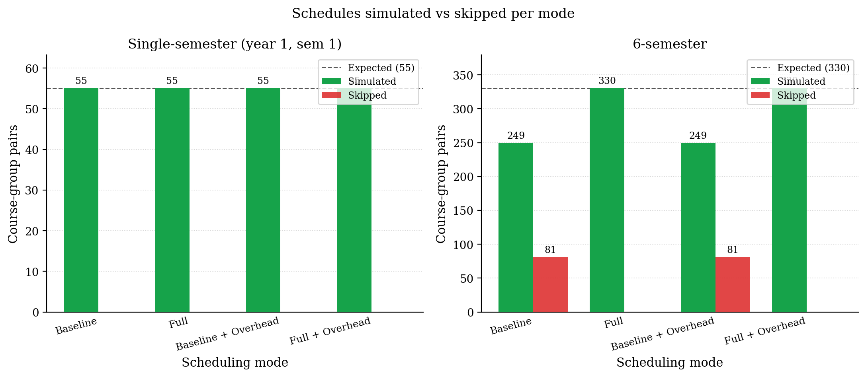
Figure 10. Schedules simulated vs skipped for 1-semester runs
Figure 11 shows the same comparison across six semesters, where the structural weakness of the baseline strategy becomes visible. The baseline and baseline + overhead modes completed only 249 assignments and skipped 81 course-group pairs, while the full and full + overhead modes completed the full expected total of 330 with no skips. The cause of baseline's skipped assignments is structural: the first-available strategy always assigns the first professor returned by the per-course query. Once that professor's time slots are exhausted, every later course taught by them is forced to skip. The full strategy avoids this by selecting the least-loaded professor at each step, distributing assignments across the available professor pool and preventing capacity bottlenecks over time. The overhead setting does not change this outcome; it only affects timing calculations, not the professor-selection logic.

Figure 11. Schedules simulated vs skipped for a 6-semester run

IV.5 Timing breakdown by component

Figure 12 splits total_ms into algorithm, authentication, database read, database write, and rollback buckets. Across all four modes the algorithm itself accounts for less than ten percent of wall-clock time, and the rest goes to database I/O. Each bar shows the mean over 11 iterations, and the error bar on top of each stack reports the standard deviation of total_ms for that mode. The per-bucket spreads are not stacked because they are positively correlated (a slow iteration is slow across every bucket), and stacking them would overstate the spread.
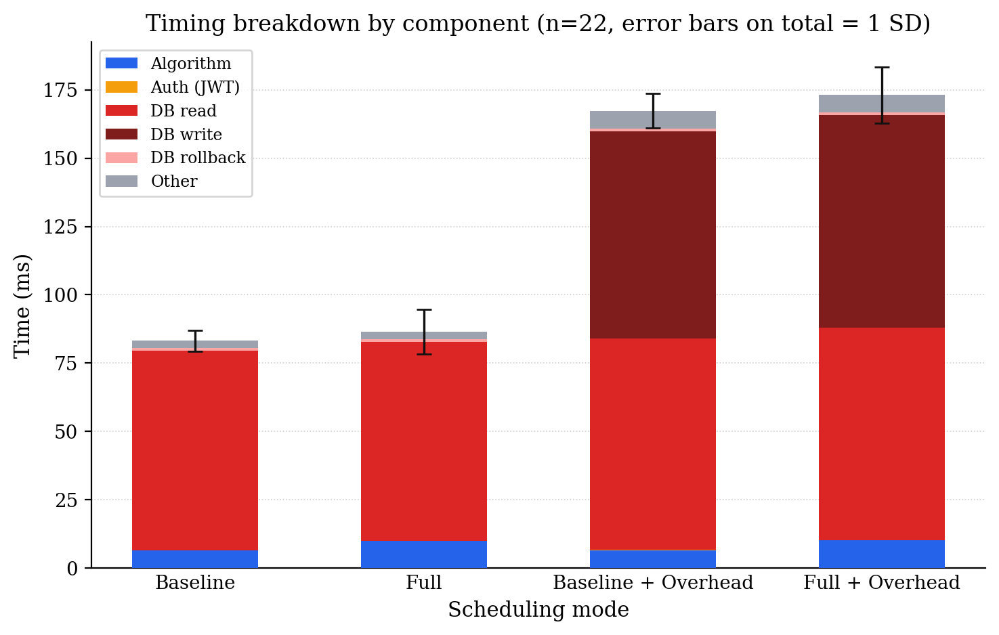
Figure 12. Timing breakdown by component (n = 11, error bars on total = 1 SD)

Figure 13 expresses the same breakdown as a pair of pies, one per realistic mode. Authentication is negligible (under one percent of every realistic run), and the bulk of the time goes to reads and writes in roughly equal share. Rollback stays small even when more than a hundred inserts must be unwound in full_realistic, which means the cost comes mostly from the surrounding I/O rather than from undo logging itself.
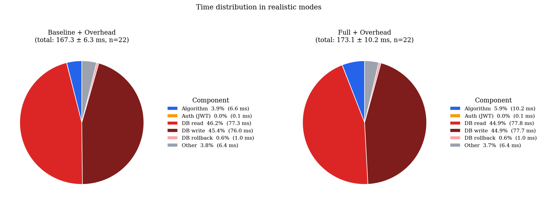
Figure 13. Time distribution in realistic modes

IV.6 Single-semester vs 6-semester

Figure 14 contrasts single-semester runtime against full-school runtime per mode, with error bars on both bars in every pair. The full-school workload contains six times more assignments than the single semester (330 vs 55), but no mode took six times as long.
Scaling came out sub-linear in every configuration, which fits the structure of the benchmark. The bulk read queries at the top of each _run_single call are paid once per (year, semester) pair regardless of how many assignments come out of that pair, so amortising those reads across more assignments lowers the per-assignment cost. The per-assignment work, which is the slot-and-room search and, in the realistic modes, the two flushes, scales linearly with the number of assignments. The combined effect is a runtime curve that grows much more slowly than the workload itself.
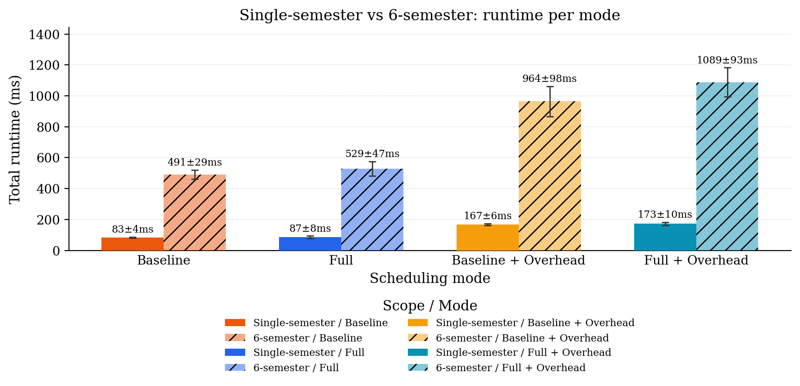
Figure 14. Single semester vs full school, runtime per mode

IV.7 Run-to-run stability

Figure 15 reports the mean and standard deviation of total_ms for each mode on the single-semester workload across 11 iterations. The plain modes show tighter spreads than the realistic ones, which is expected: every additional path through the connection pool and the write-ahead log adds another source of jitter. The gap between baseline and full is larger than the standard deviation of either, so the runtime difference between selection strategies survives the noise floor. The same is true for the gap between the plain and realistic variants of each strategy, which confirms that the overhead of authentication and per-insert flushes is a real cost and not a measurement artefact.
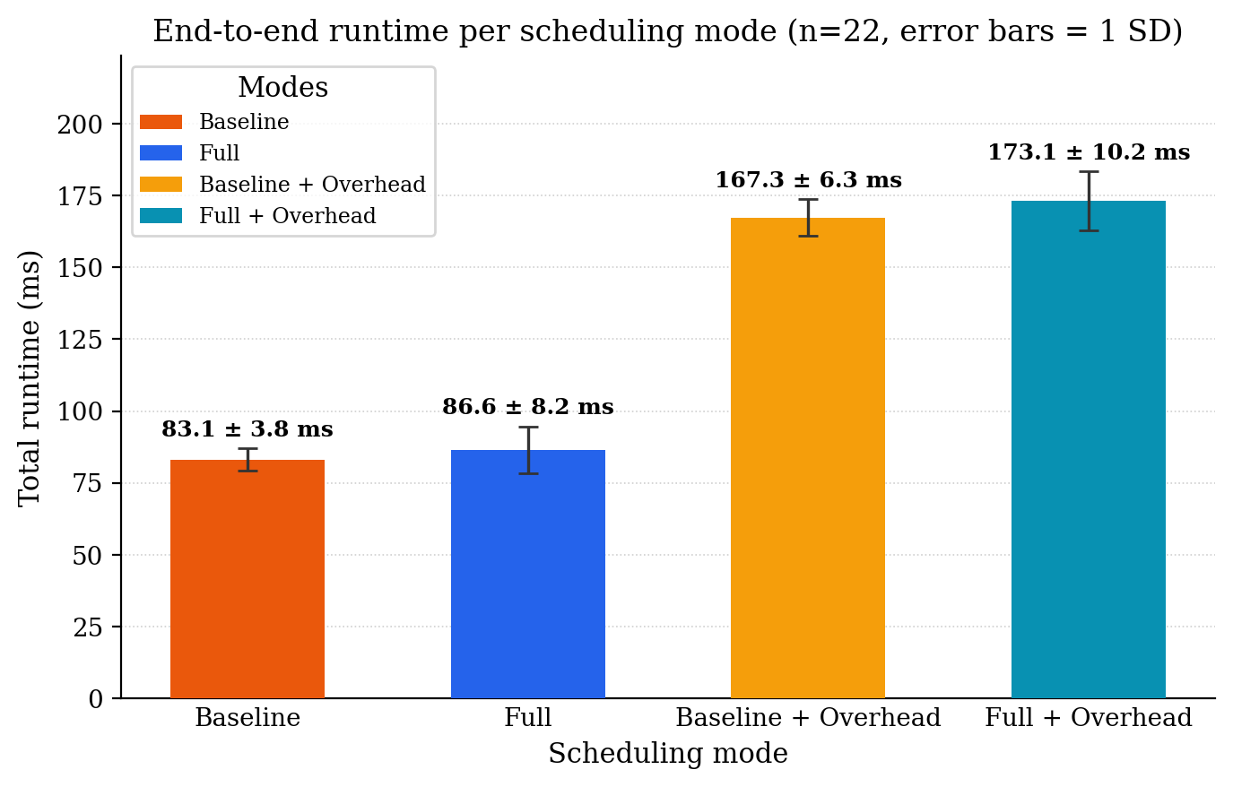
Figure 15. End-to-end runtime per scheduling mode (n = 11, error bars = 1 SD)

Figure 16 plots the same data as a per-iteration history. The first iteration of each mode is consistently slower than the rest, which is the cold-cache effect on the PostgreSQL buffer pool. Subsequent iterations cluster tightly within roughly one standard deviation of the mean. The number of placed schedules was identical across all 11 iterations of every mode, which confirms that the order_by(Prof.u_id) introduced earlier in this chapter is sufficient to make the scheduler deterministic on a fixed input.
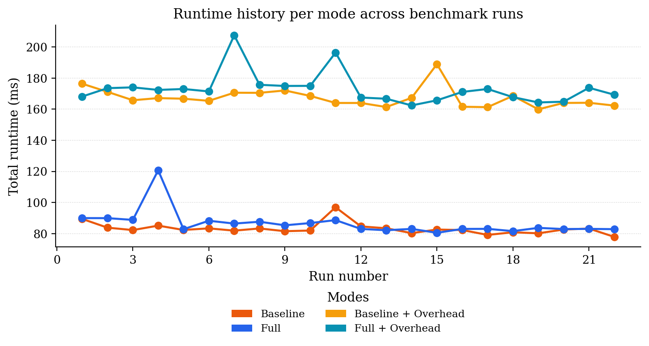
Figure 16. Runtime history per mode across benchmark runs

IV.4 Discussion

IV.4.1 Meaning Behind The Benchmark

The point of running four modes was never to crown a winner. baseline and full are not interchangeable choices, and the realistic variants are not optional configurations either. The pair exists to separate two distinct questions: how much does the smart strategy cost over the naive one, and how much does the surrounding infrastructure cost over the algorithm itself. The results answer both.
The smart strategy spends a few extra milliseconds of algorithm time per request, and the infrastructure roughly doubles total runtime when authentication and database writes are placed inside the measured path. That trade-off is decisively worth it. The small extra cost of the scored selection buys complete feasibility on the 6-semester workload, where baseline drops 81 of 330 assignments.
A scheduler that places only 75 percent of courses is not a working scheduler in any practical sense, since the missed courses still must be placed somehow, usually by hand, which costs a department secretary far more than the few milliseconds saved by skipping the score computation.

IV.4.2 Runtime Distribution

Two findings stand out in the timing breakdown. First, the algorithm itself is a rounding error. Even in full_realistic at 6-semester scale, find_slot_and_room accounts for under ten percent of the elapsed time. Anyone hoping to make the scheduler faster by optimizing the search is optimising the wrong thing. The reads and writes wrapped around the algorithm are where the cost lives.

Second, authentication is genuinely negligible. The JWT decode finishes in well under a millisecond and contributes nothing meaningful to total runtime. That matters because there has been pressure to remove auth from the auto-schedule endpoint on the grounds that it slows requests down. The data does not support that argument. Stripping the JWT decode would save roughly a tenth of a percent of the request time, in exchange for losing access control entirely.

IV.4.3 Scaling behaviour

The 6-semester workload is six times the single-semester workload by assignment count, but no mode took six times as long. Every mode came out sub-linear in time-per-assignment. The reason is structural rather than algorithmic. The bulk reads at the top of _run_single (loading curriculum, rooms, slots, and professor availability) are paid once per (year, semester) pair regardless of how many courses follow. Amortising those fixed costs across more assignments lowers the per-assignment cost.

The practical implication is that generating a full school's worth of schedules is closer in elapsed time to generating one semester than the assignment count would suggest. Running the scheduler on the whole school once per term is cheaper, in cumulative API time, than running it on individual semesters separately. That is a useful piece of intuition for whoever ends up operating the system in deployment.

IV.4.4 Practical takeaways

For the running scheduler, the results point to three concrete conclusions. Use full mode in production, since the algorithmic cost is small and the feasibility benefit is decisive. Avoid pouring optimisation effort into the slot-search itself, since database I/O dominates every request and any algorithmic speedup would be invisible in the wall reading. And treat 6-semester generation as a feasible operation rather than a heavy batch job, since the per-assignment cost goes down with workload size, not up.

Conclusion and Future Work
The main contribution of this thesis is the development of a complete university course scheduling system and the evaluation of two scheduling strategies on a realistic faculty-sized dataset. The system consists of a FastAPI backend, a Next.js frontend, and a PostgreSQL database. Schedule generation is driven by the curriculum, where each active CourseCurriculum entry creates a CourseSchedule with one lecture and one seminar for every assigned student group. Two scheduling approaches were tested. The baseline strategy assigns the first available slot that satisfies the constraints, while the full strategy evaluates candidate slots using the day_session_score heuristic together with same-day penalties, difficulty weighting, and shared-room logic for combined lectures.
The benchmark results show that the additional logic used by the full strategy has only a small impact on runtime while significantly improving scheduling quality. On the full-school dataset, the runtime increased by around three percent, but all 330 course offerings were scheduled successfully. In comparison, the baseline strategy scheduled 249 offerings and skipped 81. The validator reported no room, group, or professor conflicts in the generated schedules. The results also show that runtime grows approximately linearly with the size of the dataset. Most of the execution time comes from database operations rather than from the scheduling algorithm itself, which suggests that future optimisation should focus on the database layer.
The evaluation was performed on one synthetic dataset and one hardware configuration, so the exact performance numbers may differ on larger datasets or different systems. The benchmarks also measure only the scheduling process itself and do not include network overhead that would exist in a production deployment. However, since all scheduling modes were tested under the same conditions, the comparison between them remains valid. Future work could include schedule versioning, improved manual editing tools in the frontend, stronger professor availability constraints, and the evaluation of exact optimisation methods such as integer programming for cases where heuristic scheduling may not be sufficient.

References
Bogner, J., Wojcik, P., & Zimmermann, O. (2024). How do microservice API patterns impact understandability? A controlled experiment. arXiv. https://arxiv.org/abs/2402.13696
Ceschia, S., Di Gaspero, L., & Schaerf, A. (2022). Educational timetabling: Problems, benchmarks, and state-of-the-art results. arXiv. https://arxiv.org/abs/2201.07525
Chen, K. (2025). Improving front-end performance through modular rendering and adaptive hydration (MRAH) in React applications. arXiv. https://arxiv.org/abs/2504.03884
Davison, M., Kheiri, A., & Zografos, K. G. (2024). Modelling and solving the university course timetabling problem with hybrid teaching considerations. PubMed Central. https://pmc.ncbi.nlm.nih.gov/articles/PMC12130172/
Dunke, F., & Nickel, S. (2023). A matheuristic for customized multi-level multi-criteria university timetabling. Annals of Operations Research. https://pmc.ncbi.nlm.nih.gov/articles/PMC10080184/
Kiyohara, M., & Ishihata, M. (2024). A constraint programming approach to fair high school course scheduling. arXiv. https://arxiv.org/abs/2408.12032
Kotstein, S., & Bogner, J. (2021). Which RESTful API design rules are important and how do they improve software quality? A Delphi study with industry experts. arXiv. https://arxiv.org/abs/2108.00033
Lyu, Y., Shen, Y., & Matsuzawa, T. (2026). Educational database prototype: The simplest of all. arXiv. https://arxiv.org/abs/2601.19165
Pati, S., & Zaki, Y. (2025). Evaluating the efficacy of Next.js: A comparative analysis with React.js on performance, SEO, and global network equity. arXiv. https://arxiv.org/abs/2502.15707
[Siberian Federal University authors]. (2023). Designing an education database in a higher education institution for the data-driven management of the educational process. Education Sciences, 13(9), 947. https://www.mdpi.com/2227-7102/13/9/947
Ye, T., Jovine, A. S., van Osselaer, W., Zhu, Q., & Shmoys, D. B. (2024). Cornell University uses integer programming to optimize final exam scheduling. arXiv. https://arxiv.org/abs/2409.04959
SQLAlchemy Authors. (2024). SQLAlchemy documentation. Retrieved May 2026, from https://docs.sqlalchemy.org
The PostgreSQL Global Development Group. (2024). PostgreSQL documentation. Retrieved May 2026, from https://www.postgresql.org/docs/
Uvicorn documentation. Retrieved May 2026, from https://www.uvicorn.org
python-dotenv documentation. Retrieved May 2026, from https://saurabh-kumar.com/python-dotenv/
FastAPI documentation. Retrieved May 2026, from https://fastapi.tiangolo.com
Next.js documentation. Retrieved May 2026, from https://nextjs.org/docs
Microsoft. TypeScript documentation. Retrieved May 2026, from https://www.typescriptlang.org/docs/
Jones, M., Bradley, J., & Sakimura, N. (2015). JSON Web Token (RFC 7519). Internet Engineering Task Force. https://datatracker.ietf.org/doc/html/rfc7519
OWASP Foundation. (2024). JSON Web Token cheat sheet for Java. Retrieved May 2026, from https://cheatsheetseries.owasp.org/cheatsheets/JSON_Web_Token_for_Java_Cheat_Sheet.html
Ramírez, S. (2024). FastAPI security documentation. Retrieved May 2026, from https://fastapi.tiangolo.com/tutorial/security/
JWT Authentication. Medium, Retreived June 2026 from https://medium.com/@btanisha528/jwt-explained-211027d49153
Password Hashing, Medium, Retreived June 2026 from https://medium.com/@bhupendra_Maurya/password-hashing-using-bcrypt-e36f5c655e09

Bibliography
Bogner, J., Wojcik, P., & Zimmermann, O. (2024). How do microservice API patterns impact understandability? A controlled experiment. arXiv. Retrieved from https://arxiv.org/abs/2402.13696
Ceschia, S., Di Gaspero, L., & Schaerf, A. (2022). Educational timetabling: Problems, benchmarks, and state-of-the-art results. arXiv. Retrieved from https://arxiv.org/abs/2201.07525
Chen, K. (2025). Improving front-end performance through modular rendering and adaptive hydration (MRAH) in React applications. arXiv. Retrieved from https://arxiv.org/abs/2504.03884
Davison, M., Kheiri, A., & Zografos, K. (2024). Modelling and solving the university course timetabling problem with hybrid teaching considerations. PubMed Central. Retrieved from https://pmc.ncbi.nlm.nih.gov/articles/PMC12130172/
Dunke, F., & Nickel, S. (2023). A matheuristic for customized multi-level multi-criteria university timetabling. Annals of Operations Research. Retrieved from https://pmc.ncbi.nlm.nih.gov/articles/PMC10080184/
Encode OSS. (n.d.). Uvicorn documentation. Retrieved from Uvicorn: https://www.uvicorn.org
Jones, M., Bradley, J., & Sakimura, N. (2015). JSON Web Token (RFC 7519). Internet Engineering Task Force. Retrieved from https://datatracker.ietf.org/doc/html/rfc7519
Kiyohara, M., & Ishihata, M. (2024). A constraint programming approach to fair high school course scheduling. arXiv. Retrieved from https://arxiv.org/abs/2408.12032
Kotstein, S., & Bogner, J. (2021). Which RESTful API design rules are important and how do they improve software quality? A Delphi study with industry experts. arXiv. Retrieved from https://arxiv.org/abs/2108.00033
Lyu, Y., Shen, Y., & Matsuzawa, T. (2026). Educational database prototype: The simplest of all. arXiv. Retrieved from https://arxiv.org/abs/2601.19165
Maurya, B. (2026, June). Password hashing using bcrypt. Retrieved from Medium: https://medium.com/@bhupendra_Maurya/password-hashing-using-bcrypt-e36f5c655e09
Microsoft Corporation. (n.d.). TypeScript documentation. Retrieved from TypeScript: https://www.typescriptlang.org/docs/
OWASP Foundation. (2024). JSON Web Token cheat sheet for Java. Retrieved from OWASP Cheat Sheet Series: https://cheatsheetseries.owasp.org/cheatsheets/JSON_Web_Token_for_Java_Cheat_Sheet.html
Pati, S., & Zaki, Y. (2025). Evaluating the efficacy of Next.js: A comparative analysis with React.js on performance, SEO, and global network equity. arXiv. Retrieved from https://arxiv.org/abs/2502.15707
Ramirez, S. (2024). FastAPI security documentation. Retrieved from FastAPI: https://fastapi.tiangolo.com/tutorial/security/
Ramirez, S. (n.d.). FastAPI documentation. Retrieved from FastAPI: https://fastapi.tiangolo.com
Saurabh Kumar. (n.d.). python-dotenv documentation. Retrieved from python-dotenv: https://saurabh-kumar.com/python-dotenv/
Siberian Federal University. (2023). Designing an education database in a higher education institution for the data-driven management of the educational process. Education Sciences, 13(9), 947. Retrieved from https://www.mdpi.com/2227-7102/13/9/947
SQLAlchemy Authors. (2024). SQLAlchemy documentation. Retrieved from SQLAlchemy: https://docs.sqlalchemy.org
Tanisha, B. (2026, June). JWT explained. Retrieved from Medium: https://medium.com/@btanisha528/jwt-explained-211027d49153
The PostgreSQL Global Development Group. (2024). PostgreSQL documentation. Retrieved from PostgreSQL: https://www.postgresql.org/docs/
Vercel. (n.d.). Next.js documentation. Retrieved from Next.js: https://nextjs.org/docs
Ye, T., Jovine, A., van Osselaer, W., Zhu, Q., & Shmoys, D. (2024). Cornell University uses integer programming to optimize final exam scheduling. arXiv. Retrieved from https://arxiv.org/abs/2409.04959

Appendix A: Data

